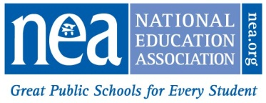
NATIONAL EDUCATION ASSOCIATION
2016-17 Student Rebate Application

Complete form and mail, email OR fax on or before MAY 1, 2017 to:
NEA Membership Management Services, ATTN: Student Rebates

Mail: Email: Fax:
1201 16th Street, NW, Ste. 419 studentrebate@nea.org (202) 822-7669
Washington, DC 20036-3290

PLEASE CLEARLY PRINT or TYPE
NEA INDIVIDUAL ID
or Social Security Number
First NAME: |  | last name:
former last name if needed to verify mbshp
Address:
CITY: |  |  | STATE: |  |  | ZIP:
PERSONAL EMAIL ADDRESS:

Rebate of $20 for each year you held a Student membership up to four years will be issued provided the following requirements are met:

- 2016-17 must be your first year of educational employment and you must currently hold NEA Active membership. Substitute members are not eligible for the rebate.
- The application must be submitted to NEA by May 1, 2017. Be certain to provide ALL requested information.
- Verification of your membership and eligibility will be made by NEA and a rebate check will be mailed to the address on the application in late August 2017. If your address changes before August 2017 please send the updated address to studentrebate@nea.org
- NEA will not contact you prior to mailing your rebate check unless additional information is required. DO NOT SUBMIT MULTIPLE APPLICATIONS. This could delay processing!!
Below is a record of my college or NEA chapter/state affiliate while I was a NEA Student member:
Year(s) NEA STUDENT MEMBERSHIP Was Held, e.g., 2015-2016 | NEA CHAPTER & STATE or COLLEGE WHEN  STUDENT MEMBERSHIP WAS HELD
I certify that I held NEA Student membership and meet all the eligibility requirements described
above, including that I currently hold a NEA Active membership in the following NEA State Affiliate:

SIGNATURE: DATE:

For NEA Use Only

